**Business Case**: A business case outlines the **objectives**, **strategies**, and **projected outcomes**, providing a clear roadmap for navigating the complexities of the business landscape.

**Gap Analysis** – to identify areas for improvement across various dimensions of organizational effectiveness and develop targeted interventions to address these challenges.

The Nadler-Tushman Congruence Model

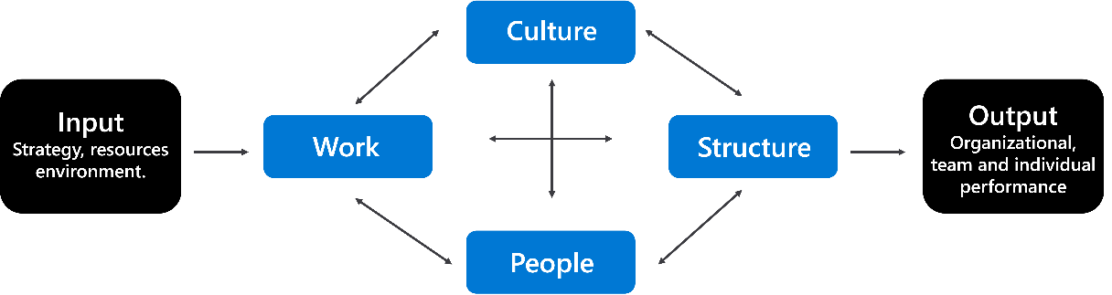

FEEDBACK

THROUGHPUTS

(Process)

OUTPUT

INPUT

The McKinsey 7S Framework

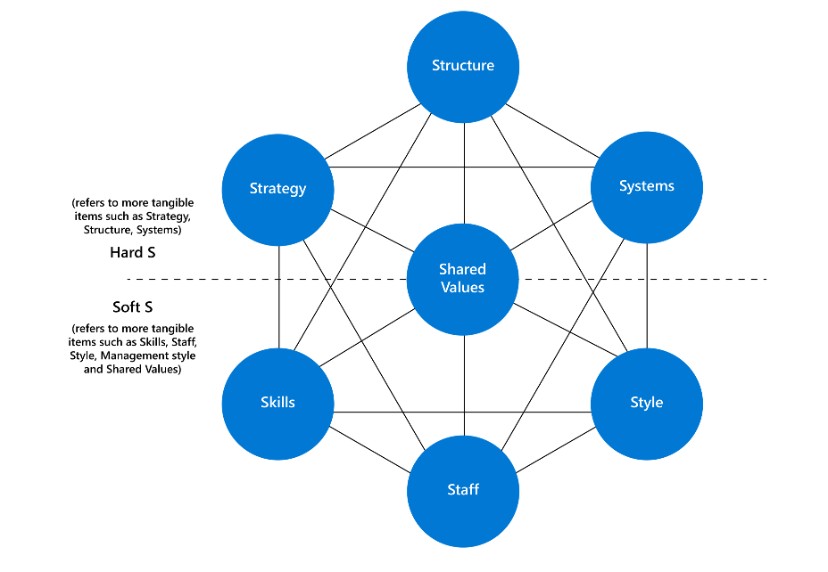

**Capability Analysis** – conducting capability assessment and constructing capability map. Define core capability, which is the top level, then breakdown into second level. Shouldn’t have more than 3 levels.

**Business Case Document –** aims to analyze various solutions to a business problem and justify the chosen solution based on factors like cost, benefits, and feasibility.

Impact Analysis - a way to anticipate how changes affect people, organizations, processes, information, and technology (POPIT).